MC900445190[1]dglxasset[1]

Phone: 403-8453711 ext 1137

Fax: 403-8457475

E-mail: justin.klein@wrsd.ca

West Central High School

5506 - 50th Street

Rocky Mountain House, AB

T4T 1W7

**Registration Form (Cont’d)**

Deadline Date: February 11, 2016

In case of an emergency, where parent or guardian cannot be reached, please list the name of someone who has permission to act on your behalf:

**Emergency Contact’s Name:** _______________________________________**Emergency Contact’s Phone Number:**

(_____) _________________________

**Relationship to Player:** _______________________________________

West Central High School, its officers, agents and employees are not responsible for any lost or damaged valuables, nor are they responsible for any illness or injury sustained during camp. My child is physically fit, except as listed above, and has my permission to participate in all camp activities. In the event of illness or injury requiring emergency medical attention and I cannot be contacted, I hereby authorize the camp staff to act for me according to their best judgement. I understand that by signing this, I forever relieve the school and camp staff of any responsibility for any illness or injury that may occur during camp.

Parent Signature:

_____________________________________

Date: _____________________

**Please detach and return completed registration form along with check for $40.00 made payable to:**

**West Central High School**

**5506 50 Street**

**Rocky Mountain House, Alberta**

**T4T 1W7**

**Camp Being Putting On By :**

**West Central Senior Boys Basketball Team**

**Hosted By:**

**Ecole Rocky Elementary**

Little Rebels Basketball Camp

Little Rebels Basketball Camp

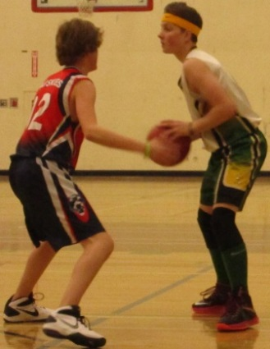

Little Rebels Basketball Registration

**Athlete Name:**

____________________________________

**D.O.B. (DD/MM/YY):** ______________

**School:** ______________________________

**Home Address:**

____________________________________

(Street) (City)

Postal Code: ______________

Home Phone Number:

(_____) ___________________

Parent or Guardian's Name: _____________________________________

Email ________________________________

Shirt Size (Youth Sizes, Please Circle)

S M L XL

Please list any medical conditions that the staff should be aware of:

_______________________________________________________________________________________________________________

### 

**Camp Dates**

*Feb. 11th, 2016*

*Feb. 25th, 2016*

*March 3rd, 2016*

*March 10th, 2016*

*March 17th, 2016*

*March 23rd, 2016*

Camp will run from 4:00 pm until 5:30pm on Thursdays. The Camp will be hosted by ERE (Ecole Rocky Elementary)

The Little Rebels Basketball Camp experience will be a positive one where fun and learning are put at the forefront.

The camp will focus on fundamental basketball skill development. The skills that will be emphasized are dribbling, ball handling, passing, lay-ups and shooting.

The camp will be run by Justin Klein (Athletic Director and Senior Boys Basketball Coach) along with at least 3 member of the senior boys’ basketball team per session.

This camp is for athletes interested in basketball in grades 4 & 5.

The cost is $40.

* 50 ATHLETE MAXIMUM FOR THE CAMP *

Registration fees will only be accepted at West Central. Registration Deadline is February 11th 2016

# **Camp Details**

Little Rebels Basketball Registration

**Athlete Name:**

____________________________________

**D.O.B. (DD/MM/YY):** ______________

**School:** ______________________________

**Home Address:**

____________________________________

(Street) (City)

Postal Code: ______________

Home Phone Number:

(_____) ___________________

Parent or Guardian's Name: _____________________________________

Email ________________________________

Shirt Size (Youth Sizes, Please Circle)

S M L XL

Please list any medical conditions that the staff should be aware of:

_______________________________________________________________________________________________________________